PRODUCT CASE STUDY • AI/ML PRODUCT BLUEPRINT
AI Return Reduction Engine
Smart Shopping AI
Reducing E-Commerce Product Returns Through Predictive AI,
Explainable Risk Scoring, and Real-Time Automation
Domain: E-Commerce & Retail Technology | Discipline: Applied AI / ML Product Strategy
Version 2.0 — June 2026

1. Executive Summary
Product returns are one of the most expensive, recurring, and under-addressed cost centers in online retail. Industry-wide, return rates for apparel and footwear regularly exceed 20–30%, and a large share of that volume traces back to a small set of preventable causes: wrong size, mismatched expectations, and thin product information.
The AI Return Reduction Engine (“Smart Shopping AI”) is a pre-purchase intelligence layer that predicts the probability a specific product will be returned by a specific shopper — before checkout. It does not simply flag risk; it explains the reasoning, recommends a corrected size or alternative product, and learns from every outcome to improve future predictions.
This document presents the complete product blueprint: market context, competitive landscape, user research, solution architecture, the eleven AI engines that compose the system, technical and data architecture, the explainability framework, automation design, requirements, KPIs, financial modeling, risk management, responsible-AI commitments, and a phased roadmap.
Core Thesis
Returns are not primarily a logistics problem — they are a decision-quality problem. Intervening with explainable, personalized risk information at the moment of purchase is more effective and lower-cost than optimizing the reverse-logistics pipeline after the fact.

Key Outcomes This Document Argues For
- A measurable reduction in avoidable returns (size- and fit-related, specifically) within two quarters of full rollout.
- A transparent, explainable risk score shown to the shopper before purchase, not hidden in a backend dashboard.
- A compounding data asset: every transaction — kept or returned — improves the next prediction.
- A phased rollout that de-risks investment, starting with a single high-return category before platform-wide expansion.

2. Market Research & Industry Analysis
E-commerce returns have grown alongside online retail itself, and apparel/footwear categories consistently show the highest return rates of any product vertical due to the irreducible problem of fit. This section frames the scale and shape of the problem the product is built to solve.

2.1 Industry Scale
- Online apparel and footwear return rates are structurally higher than other e-commerce categories because size and fit cannot be verified before delivery.
- Return processing is not free: each returned unit incurs reverse shipping, inspection, repackaging, markdown, or write-off cost — frequently consuming a meaningful share of the original order's margin.
- “Bracketing” — customers intentionally ordering multiple sizes of the same item with the explicit intent to return the ones that don't fit — has become a normalized shopping behavior on many platforms, inflating both shipping cost and carbon footprint.
- Free and frictionless return policies, while a competitive necessity for conversion, directly subsidize this behavior and shift the cost burden onto the retailer.

2.2 What's Driving the Trend
Trend | Implication for the Product
Growth of mobile-first shopping | Smaller screens reduce time spent reading size charts — increases impulse, low-information purchases.
Rise of fast-fashion catalogs | Inconsistent sizing across thousands of SKUs makes a single static size chart unreliable.
Sustainability pressure | Retailers and regulators increasingly scrutinize the environmental cost of reverse logistics, creating an ESG incentive to reduce returns at the source.
Margin compression in retail | As acquisition costs rise, retailers can no longer absorb return costs as a routine expense — prevention becomes a margin lever, not just a CX nicety.
Consumer expectation of personalization | Shoppers increasingly expect platforms to “know” their size and preferences, similar to streaming and ad personalization.

2.3 Strategic Opportunity
No dominant, category-agnostic standard exists yet for pre-purchase return-risk prediction with full explainability. Most platforms address returns reactively (easier return policies, faster refunds) rather than predictively (preventing the wrong purchase from happening). This is the white space the product targets.

3. Problem Statement
Online shopping removes the ability to physically try on or inspect a product before buying. This single gap in the experience is responsible for a large share of the return volume that e-commerce and fashion platforms absorb every year. The core drivers are summarized below.
Issue | Why It Happens
Wrong size selection | Shoppers cannot try before buying; size charts vary by brand and are frequently misread or ignored.
Product mismatch | Photos, descriptions, and marketing copy often set expectations the physical product does not meet.
Poor product information | Thin or inconsistent listings (material, fit, true-to-size notes) leave shoppers guessing.
Lack of personalization | Generic recommendations ignore the shopper's body type, history, and preferences.
High return cost | Reverse logistics, restocking, refurbishing, and write-offs erode margin on every returned item.
Customer dissatisfaction | A poor fit or mismatch experience damages trust and reduces repeat purchase rate.

Project Goal
Reduce product return rate using AI prediction, personalization, and real-time automation — by intervening before purchase rather than reacting after delivery.

3.1 Real-World Evidence
The patterns described above are not theoretical. The reviews below were collected from live customer-review platforms for major Indian e-commerce players (Meesho, Myntra) and illustrate the exact failure modes this product is designed to prevent: wrong/incomplete products reaching the buyer, missed delivery windows, exchange options that don't actually solve the size problem, and the resulting loss of customer trust.
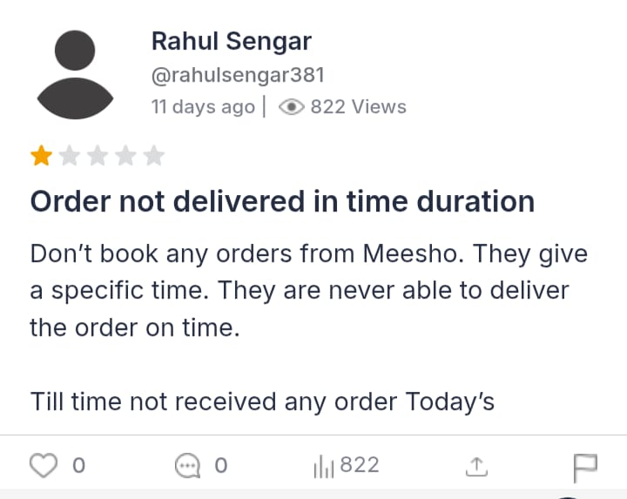
Fig 3.1 — Meesho customer review: order not delivered within the promised time window.

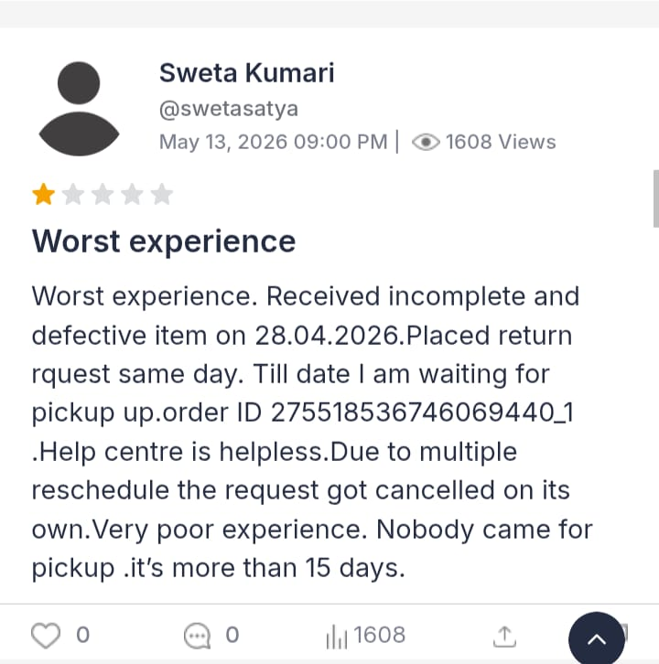
Fig 3.2 — Meesho customer review: incomplete/defective item received; return pickup never completed despite 15+ days.

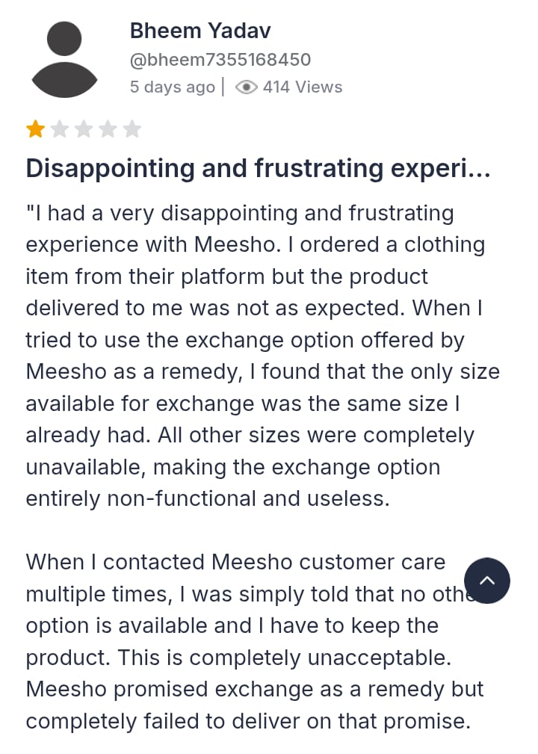
Fig 3.3 — Meesho customer review: exchange offered as a remedy, but the only available size was the same size already owned — illustrating exactly the gap the Smart Size Recommendation Engine (Section 12.6) is designed to close.

4. Why Existing Solutions Fail
Most platforms have already invested in return-reduction tooling. The reason the problem persists is not lack of effort — it's that existing approaches address the symptom, not the decision point.

4.1 Common Existing Approaches and Their Limits
Existing Approach | Core Limitation
Static size charts | Assume the shopper will read and correctly interpret them; ignore brand-to-brand inconsistency and body-type variance.
Generic size-recommendation widgets (“Find your fit” quizzes) | One-time, self-reported input with no continuous learning from actual return outcomes; quickly goes stale.
Customer reviews and Q&A sections | Unstructured, not personalized to the viewer, and require the shopper to manually search and cross-reference.
Lenient return policies | Reduces purchase friction but does nothing to prevent the wrong purchase — it subsidizes the problem rather than solving it.
Post-purchase return surveys | Reactive by design; the cost (shipping, restocking, dissatisfaction) is already incurred by the time the data is collected.
Rule-based “size up if between sizes” heuristics | Not personalized, not explainable beyond a generic rule, and doesn't account for product-specific fit issues.

4.2 The Structural Gap
Each of these approaches operates either before the platform has any data on the shopper (static charts, quizzes) or after the cost has already been incurred (returns, surveys). None of them combine three things simultaneously: real personalization, real-time prediction at the point of decision, and a continuously learning model that improves with use.
The Gap This Product Closes
A system that predicts risk for this user and this product, explains why in plain language, and acts in the moment — before the order is placed, not after it's returned.

4.3 Evidence: What Falls Through Today's Gaps
The two reviews below show how quality-control and listing-accuracy failures still reach the customer under existing systems — failures a Product Trust Score and Product Risk Tags (Section 12.2) are designed to catch before purchase, not after delivery.
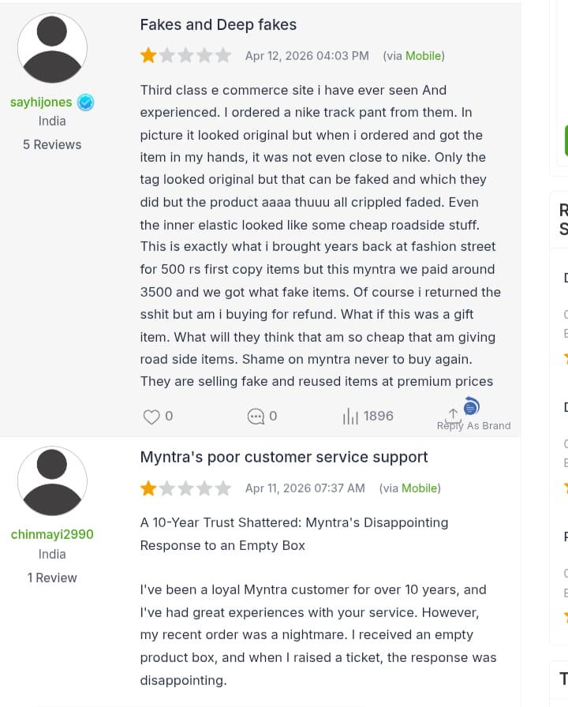
Fig 4.1 — Myntra customer review describing a product that did not match its listing (“Fakes and Deep fakes”) — a textbook expectation-mismatch case.

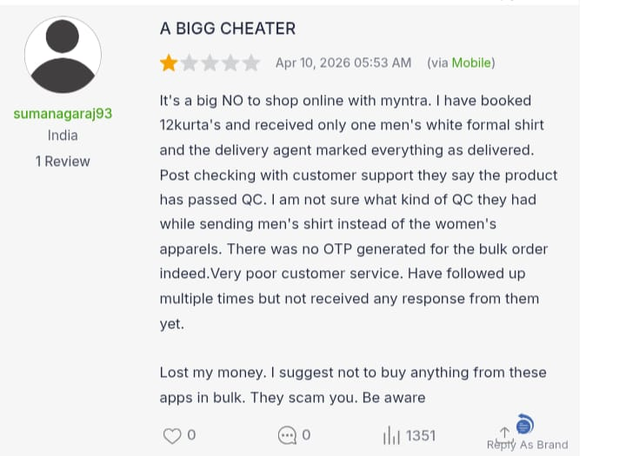
Fig 4.2 — Myntra customer review: bulk order marked “delivered” and passed as QC-approved despite containing the wrong items entirely — illustrating why explainable, auditable risk tagging (Section 16) matters even for operational/QC failures, not just sizing.

5. Competitive Analysis
The competitive landscape spans three categories: dedicated size-recommendation vendors, broad personalization/recommendation platforms, and in-house tooling built by large retailers. None fully solve the explainability and pre-purchase risk-prevention problem this product targets.

5.1 Landscape Map
Category | Examples of Approach | Strength | Gap vs. This Product
Dedicated fit/size widgets | Embedded “What's my size” tools on product pages | Easy to integrate; improves conversion | No explanation depth; rarely factors in product-level review-driven risk tags
General recommendation engines | “You may also like” / similarity-based engines | Mature, well-understood ML stack | Optimized for engagement and conversion, not return-risk reduction
In-house retailer tooling | Custom analytics built by large platforms | Deep access to proprietary data | Usually backend-only (merchandising insight), not surfaced to the shopper at decision time
Manual review-mining (Q&A, review filters) | Shoppers self-serve by searching reviews | Zero engineering cost to the retailer | Entirely manual, unpersonalized, and easy to skip

5.2 Positioning
This product is positioned at the intersection of three capabilities that are each individually common but rarely combined: (1) personalized user modeling, (2) explainable, product-specific risk scoring, and (3) real-time pre-checkout intervention. The differentiation is not a single novel algorithm — it is the integration of prediction, explanation, and automated action into one continuous loop.
The screenshots below are real customer reviews left directly on a competitor's review platform. They illustrate the “manual review-mining” approach from the table above in practice: scattered, unstructured, and offering no personalized signal at the moment a shopper is deciding whether to buy.
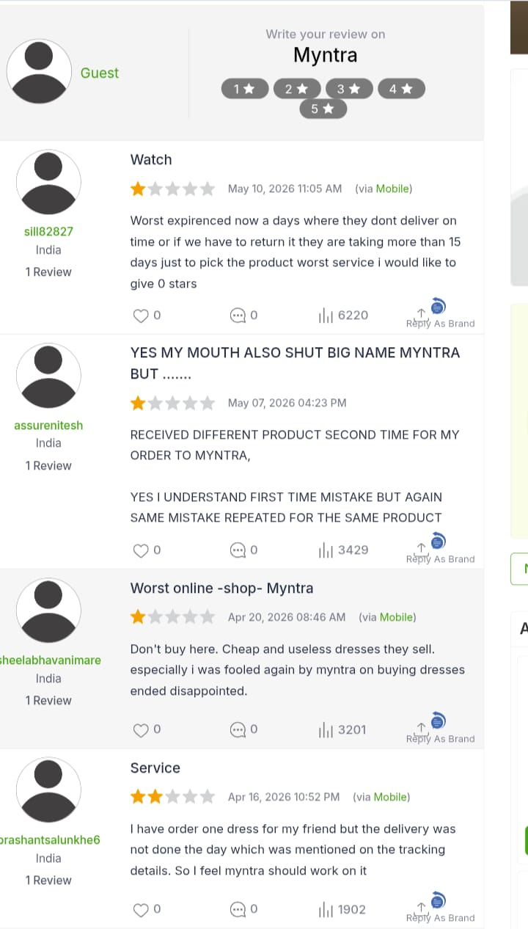
Fig 5.1 — A representative sample of unstructured Myntra customer reviews: late delivery, repeated wrong-item shipments, and poor product quality — each a separate, disconnected data point a shopper would have to find and interpret manually.

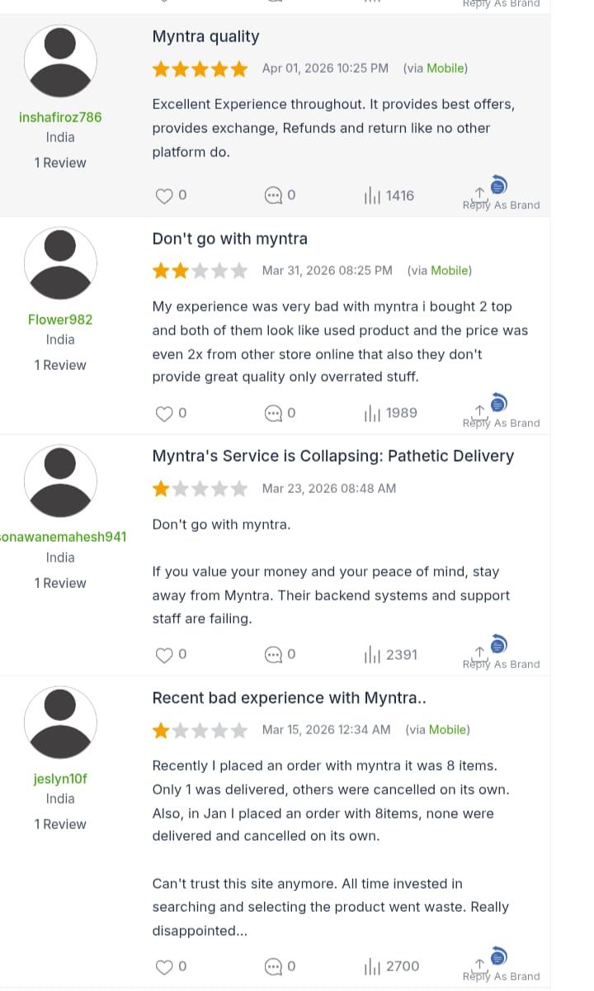
Fig 5.2 — Additional unstructured reviews, ranging from 5-star to 1-star for the same platform — demonstrating why a single aggregate star rating fails to communicate product- or user-specific risk.

5.3 Competitive Differentiation Summary
- Explainability by default — every score ships with a plain-language reason, not just a number.
- Bidirectional learning loop — both purchase and return events feed back into the model, not just purchase data.
- Pre-checkout intervention — the moment of action is before payment, not after delivery.
- Gamified shopper trust — the Smart Shopper Score creates an incentive loop competitors don't replicate.

6. Product Vision
Vision Statement
A shopping experience where every purchase decision is informed by a clear, personalized, and trustworthy prediction of fit and satisfaction — so returns become the exception, not the routine.

6.1 Vision Pillars
- Predictive, not reactive — the system acts before the order is placed.
- Transparent, not opaque — every prediction is explained in language a non-technical shopper understands.
- Personalized, not generic — recommendations reflect the individual shopper's body, history, and preferences.
- Continuously improving — the system treats every transaction as a training signal.
- Win-win economics — reduces cost for the retailer while genuinely improving the shopper's outcome, not just optimizing for fewer refund requests.

6.2 Three-Year North Star
Within three years of full deployment, the product aims to become the default pre-purchase trust layer for fashion and footwear e-commerce — expanding from size/fit prediction into a general-purpose “will I be happy with this” signal across categories beyond apparel.

7. Product Goals & Success Metrics

7.1 Primary Goals
Goal | Definition of Success
Reduce avoidable returns | Measurable decline in size/fit-attributed returns within the pilot category.
Preserve or improve conversion | Risk warnings and alternative suggestions must not meaningfully suppress checkout completion.
Build shopper trust | Sustained or rising engagement with AI recommendations over time (not a one-time novelty effect).
Establish a learning data asset | Demonstrable improvement in prediction accuracy release over release as outcome data accumulates.
Prove unit economics | Return-cost savings per order must exceed the fully loaded cost of running the prediction system.

7.2 Success Metrics (Top-Line)
- Return Rate Reduction (RRR) — percentage decline in returns for products shown a risk score, vs. a control group.
- Risk Prediction Accuracy — how often a High-Risk prediction actually resulted in a return (precision), and how many true returns were caught (recall).
- Recommendation Acceptance Rate — share of shoppers who follow a suggested size or alternative when shown one.
- Checkout Conversion Delta — change in completed-purchase rate for warned vs. unwarned sessions.
- Smart Shopper Score Engagement — percentage of returning users who check or are influenced by their score.
Full KPI definitions, targets, and instrumentation are detailed in Section 21.

8. User Personas
Three personas anchor the design decisions throughout this document: a frequent online shopper prone to size-related returns, a deal-driven occasional shopper, and an internal retail operations stakeholder who consumes the system's aggregate insights.

Persona: Maya Chen — Frequent Fashion Shopper (Primary)
Attribute | Detail
Key traits | Shops online 2–3 times a month across multiple fashion platforms; orders across 3–4 brands regularly; has returned 30%+ of apparel orders in the past year.
Goals | Wants to buy with confidence without bracketing multiple sizes; values clear, honest sizing guidance over marketing copy.
Frustrations | Size charts differ by brand; reviews are scattered and hard to trust; has been burned by 'true to size' claims that weren't.
Representative quote | “I just want to know if this will actually fit me — not read twelve reviews to guess.”

Persona: Daniel Osei — Occasional, Deal-Driven Shopper (Secondary)
Attribute | Detail
Key traits | Shops infrequently, often triggered by a sale or a specific need (e.g., an event); price-sensitive; low brand loyalty.
Goals | Wants a fast, low-effort purchase decision; doesn't want to spend time researching fit.
Frustrations | Doesn't trust generic recommendation widgets; abandons carts when uncertain about fit and can't be bothered to investigate further.
Representative quote | “If I'm not sure it'll fit, I'll just order from somewhere else — or skip it.”

Persona: Priya Nair — Retail Operations & Merchandising Lead (Internal Stakeholder)
Attribute | Detail
Key traits | Owns return-rate KPIs for a product category; reviews return reason codes weekly; works with suppliers on sizing consistency.
Goals | Wants early warning on listings with abnormal return patterns; wants data to negotiate with suppliers on sizing accuracy.
Frustrations | Return-reason data is reported after the fact and is too coarse to act on quickly; no visibility into which products are high-risk before damage is done.
Representative quote | “By the time I see the return data, we've already eaten the cost on a thousand units.”

9. Customer Journey Map
The journey below maps Maya's experience (primary persona) across the full purchase lifecycle, contrasting the current-state experience with the proposed AI-assisted experience at each stage.
Stage | Current Experience (Without AI) | AI-Assisted Experience (With Product)
Discovery | Browses product listing with generic photos and a static size chart. | Same browsing experience, but the Product Intelligence Engine has already scored the item's fit reliability in the background.
Evaluation | Manually reads scattered reviews trying to infer true-to-size fit. | Sees a personalized Return Risk Score and a plain-language reason on the product page.
Decision | Guesses a size, sometimes orders two sizes to compare (bracketing). | Receives a specific size recommendation and, if risk is high, a safer alternative product.
Checkout | Completes purchase with residual uncertainty. | If risk crosses the warning threshold, sees a clear advisory before confirming; can accept AI's suggestion via one-click optimized checkout.
Post-Purchase / Delivery | Item arrives; fit is a surprise, good or bad. | Outcome is largely de-risked because the recommendation already accounted for known fit issues.
Return (if needed) | Initiates a return; reason captured only in a coarse dropdown. | Return outcome (if any) feeds directly back into the Self-Learning Loop, refining future predictions for similar users and products.

9.1 Real-World Evidence: The Return Stage
The “Return (if needed)” stage in the table above is where today's experience breaks down most visibly. The review below documents exactly this failure: a wrong product is delivered, an exchange is refused, and no refund follows — with no clear path to resolution.
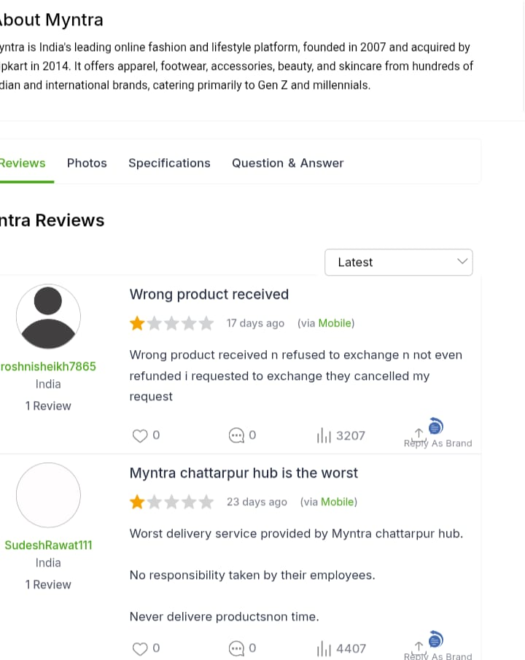
Fig 9.1 — Myntra customer reviews: wrong product delivered with exchange refused and no refund issued; a separate review reports delivery service failures at a specific fulfillment hub.

10. Proposed Solution
The Smart Shopping AI system is designed around a single principle: predict the return before it happens, and explain why, so the shopper can self-correct. The solution has five functional pillars:
- Predict product return probability before purchase.
- Explain why the product may be returned, in plain language.
- Suggest the correct size or a better-fitting alternative.
- Continuously learn from real user behavior and outcomes.
- Automate the decision-making so the system acts in real time, not just on a dashboard.
Together these pillars shift the system from a passive analytics tool into an active shopping co-pilot, woven directly into the browsing and checkout experience rather than bolted on as a separate feature.

11. Core Features Overview
Eleven engines compose the system end to end. This section gives a one-line summary of each; Section 12 details each engine's inputs, outputs, logic, and examples.
# | Engine | One-Line Summary
1 | User Profile AI Engine | Builds a behavioral and physical profile for every shopper.
2 | Product Intelligence Engine | Builds a structured, risk-aware profile for every product.
3 | Return Risk Prediction Engine | Scores return probability for a specific user-product pairing.
4 | Return Reason AI (Explainable AI) | Attaches a plain-language reason to every prediction.
5 | Virtual Fit Simulator | Estimates tight / perfect / loose fit before purchase.
6 | Smart Size Recommendation Engine | Converts fit analysis into a concrete size suggestion.
7 | Alternative Product Recommender | Surfaces safer, similar-style options when risk is high.
8 | Return Prevention Mode | Auto-warns the shopper before checkout when risk exceeds threshold.
9 | One-Click Smart Checkout | Lets the AI auto-select the safest size and variant.
10 | Smart Shopper Score | Gamifies purchase accuracy and recommendation acceptance.
11 | Future Return Prediction Timeline | Compares predicted outcomes of two purchase paths.

12. Detailed AI Engines
This section is the technical and functional core of the product. Each of the eleven engines is documented with its inputs/outputs, internal logic, a worked example, and known edge cases.

12.1 User Profile AI Engine
Builds and continuously refreshes a behavioral and physical profile for every shopper, forming the foundation every other engine personalizes against.

Inputs & Outputs
Inputs | Outputs
Height, weight, body type, stated preferences, purchase history, return history | Shopping Behavior Profile; Smart Shopper Score (0–100)

How It Works
- Collects explicit data (self-reported measurements, stated brand/style preferences) and implicit data (browsing patterns, past purchases, past returns).
- Normalizes body measurements against brand-specific size charts to build a brand-agnostic body profile.
- Updates incrementally after every transaction rather than requiring a full profile re-entry.

Example
Sample Output
User Profile: Maya Chen — Body type: pear, Preferred fit: relaxed, Past returns: 3 of last 10 orders (all 'tight in shoulders'), Smart Shopper Score: 68/100.

Edge Cases & Design Notes
- New users with no history start with a low-confidence profile based only on self-reported data; confidence rises as transaction history accumulates.
- Users who decline to share body measurements fall back to a behavior-only profile (purchase/return patterns without physical data).

12.2 Product Intelligence Engine
Builds a structured, risk-aware profile for every product in the catalog by mining listing data and customer-generated content.

Inputs & Outputs
Inputs | Outputs
Category, size chart, material, brand, price, customer reviews | Product Trust Score; Product Risk Tags (e.g., size issue, quality issue, color mismatch)

How It Works
- Parses structured listing fields (size chart, material, category) and unstructured text (reviews, Q&A) using NLP to detect recurring complaints.
- Tags products with specific risk categories rather than a single opaque score, so downstream engines can explain why risk exists.
- Re-scores products on a rolling basis as new reviews and return data arrive.

Example
Sample Output
Product: Classic Denim Jacket (Brand X) — Trust Score: 61/100, Risk Tags: [size inconsistency — high], [shoulder fit — medium].

Edge Cases & Design Notes
- New product listings with few or no reviews start with a category-average risk prior until sufficient data accumulates.
- Conflicting reviews (some say 'runs small', others say 'true to size') are surfaced as a noted inconsistency rather than averaged away silently.

12.3 Return Risk Prediction Engine
The central scoring model. For any given user-product pairing, it produces a single actionable risk number plus level and explanation.

Inputs & Outputs
Inputs | Outputs
User Profile + Product Intelligence outputs; similar-user/similar-product return patterns | Return Risk Score (0–100%); Risk Level (Low / Medium / High); explanation text

How It Works
- Combines the user's individual return history with patterns from similar shoppers (collaborative signal) and the product's own risk tags (content signal).
- Outputs a calibrated probability, not just a ranked score, so the 70% threshold used by Return Prevention Mode (Section 12.8) is meaningful.
- Risk Level buckets (Low <30%, Medium 30–70%, High >70%) give a simple at-a-glance label alongside the precise number.

Example
Sample Output
Return Risk: 78% — Risk Level: High. Reason: similar users returned this item due to tight fit; reviews mention size inconsistency.

Edge Cases & Design Notes
- Cold-start pairings (new user + new product) fall back to category-level base rates with a clearly lower confidence indicator.
- Score must be recalculated, not cached, whenever the user's profile or the product's risk tags change materially.

12.4 Return Reason AI (Explainable AI)
Ensures every prediction is accompanied by a human-readable cause, never an opaque number. This engine is detailed further in Section 16.

Inputs & Outputs
Inputs | Outputs
Return Risk Prediction Engine's internal feature weights; Product Risk Tags | Plain-language reason string mapped to a standard category

How It Works
- Translates the model's top contributing factors into one of four standard reason categories: size issue, fabric issue, expectation mismatch, quality issue.
- Prioritizes the single most influential factor rather than listing every contributing signal, to keep the explanation scannable.
- Uses consistent, non-technical phrasing reviewed for clarity rather than raw feature names (e.g., never exposes internal model variable names to the shopper).

Example
Sample Output
Reason shown to shopper: “Similar shoppers with your build returned this item due to a tight fit.”

Edge Cases & Design Notes
- When multiple reason categories are close in contribution weight, the engine surfaces the top two rather than forcing a single artificial cause.
- Reason text is logged alongside the numeric score so product and merchandising teams can audit explanations in aggregate.

12.5 Virtual Fit Simulator
An advanced layer that estimates how a specific garment will sit on a specific body, expressed as a simple three-state classification.

Inputs & Outputs
Inputs | Outputs
User body profile; product cut/material data; fit patterns reported by similar customers | Fit classification: tight / perfect / loose, by body zone where data allows (e.g., shoulders, waist)

How It Works
- Combines garment construction data (cut, stretch, material) with aggregated fit feedback from shoppers with similar body profiles.
- Where data allows, breaks the fit estimate down by body zone (e.g., 'tight in shoulders, true to size in waist') rather than a single whole-garment label.
- Falls back to a whole-garment estimate when zone-level data is insufficient.

Example
Sample Output
Virtual Fit Estimate — Denim Jacket, Size M, for Maya: Shoulders: tight, Waist: true to size, Overall: tight fit likely.

Edge Cases & Design Notes
- This is the most data-hungry engine; it is intentionally scoped as an 'advanced' / later-phase capability (see Roadmap, Section 26) rather than a Phase 1 requirement.
- Garments with high stretch/elastane content are flagged separately, since fit tolerance is inherently wider and risk should be discounted accordingly.

12.6 Smart Size Recommendation Engine
Converts fit analysis into a concrete, actionable size suggestion the shopper can act on immediately.

Inputs & Outputs
Inputs | Outputs
Virtual Fit Simulator output; brand-specific size-pattern data; similar-shopper sizing behavior | Recommended size, with confidence level

How It Works
- Cross-references the user's body profile against the specific brand's historical sizing pattern (which may differ from the brand's stated size chart).
- Weighs in how similar shoppers who kept vs. returned this item self-reported their chosen size.
- Always recommends a single primary size rather than a range, to keep the action unambiguous; confidence level communicates uncertainty separately.

Example
Sample Output
Recommended Size: S instead of M — Confidence: High (based on 240 similar shoppers' outcomes).

Edge Cases & Design Notes
- When a brand has too little sizing-pattern data, recommendation confidence is shown as Low and the engine clearly states it is using the stated size chart only.

12.7 Alternative Product Recommender
Activates whenever predicted risk is high, redirecting demand toward safer, similar-style outcomes rather than simply blocking the purchase.

Inputs & Outputs
Inputs | Outputs
High-risk product + user pairing; catalog of similar-style products with lower historical return rates | Ranked list of 2–3 alternative products

How It Works
- Filters the catalog for products in a similar style/category, then ranks by a combination of style similarity and the user-specific predicted return risk for each candidate.
- Avoids recommending alternatives purely because they're popular — the ranking signal is specifically lower predicted risk for this shopper.

Example
Sample Output
Because this item has high return risk for you, you might prefer: [Relaxed-Fit Denim Jacket — Risk: 22%] [Cropped Denim Jacket — Risk: 18%].

Edge Cases & Design Notes
- Design safeguard: alternatives are capped at 2–3 suggestions to avoid decision paralysis, and are never the only path forward — the shopper can always proceed with the original item.
- Monitored against the bias risk noted in Section 24 (over-narrowing catalog exposure toward 'safe' bestsellers).

12.8 Return Prevention Mode (Auto-Warning System)
A real-time guardrail that intercepts high-risk purchases before checkout, the most visible and highest-stakes UI moment in the system.

Inputs & Outputs
Inputs | Outputs
Real-time Return Risk Score; configurable risk threshold (default 70%) | On-screen warning banner; triggers Smart Size Recommendation and Alternative Product Recommender outputs

How It Works
- Monitors the live risk score as the shopper adds an item, size, and variant to cart.
- When risk crosses the threshold, surfaces a clearly visible (but non-blocking) warning before the Add to Cart / checkout action completes.
- Threshold is configurable per category and is a primary lever for balancing intervention frequency against alert fatigue (see Section 24).

Example
Sample Output
⚠️ High Return Risk Detected (78%) — before you continue: we recommend Size S, or these similar lower-risk styles.

Edge Cases & Design Notes
- The warning is advisory, never a hard block — shoppers retain full control to proceed with their original choice.
- Frequency of triggering is actively monitored; a sustained spike suggests the threshold needs recalibration, not just a static, set-once value.

12.9 One-Click Smart Checkout (“AI Optimized Buy”)
Lets a confident shopper delegate size and variant selection to the model entirely, trading manual selection for AI-optimized accuracy.

Inputs & Outputs
Inputs | Outputs
All upstream engine outputs for the current product | Auto-selected size and variant; one-click purchase completion

How It Works
- Surfaces as an opt-in action, never the default checkout path, so shoppers who prefer manual control are unaffected.
- Selects the single highest-confidence size/variant combination rather than presenting another decision to the shopper.

Example
Sample Output
AI Optimized Buy: Size S selected automatically (94% confidence) — complete purchase in one tap.

Edge Cases & Design Notes
- Reserved for returning shoppers with sufficient profile confidence; new users with thin profiles do not see this option until enough data exists.

12.10 Smart Shopper Score (Gamification)
A visible, evolving score that rewards shoppers for purchase accuracy and recommendation engagement, reinforcing the behavior loop.

Inputs & Outputs
Inputs | Outputs
Return history; rate of AI-recommendation acceptance; purchase accuracy over time | Smart Shopper Score (0–100), shown to the user with a brief explanation of recent changes

How It Works
- Increases when a shopper follows an AI recommendation and the resulting purchase is kept (not returned).
- Is explicitly not penalized for legitimate returns unrelated to fit/sizing (e.g., changed mind on style), to avoid discouraging honest engagement.
- Surfaced with light gamification (progress framing) rather than a punitive 'bad shopper' framing.

Example
Sample Output
Smart Shopper Score: 75/100 (+3 this month) — You kept 9 of your last 10 AI-recommended sizes.

Edge Cases & Design Notes
- Score logic is reviewed for fairness: it must not effectively penalize shoppers with harder-to-fit or non-standard body types, who may have legitimately higher historical return rates through no fault of their decision-making.

12.11 Future Return Prediction Timeline
A forward-looking comparison view that contrasts two paths for the same purchase decision, used to make the value of following AI guidance tangible.

Inputs & Outputs
Inputs | Outputs
Return Risk Score for the original selection; Return Risk Score for the AI-recommended alternative/size | Side-by-side predicted-outcome comparison

How It Works
- Presents two clearly labeled paths: the shopper's current selection and the AI's suggested adjustment.
- Translates risk percentages into plain outcome language ('return likely' / 'satisfaction high') rather than just repeating raw numbers a second time.

Example
Sample Output
If you buy as selected (Size M): return likely (78% risk). If you follow our suggestion (Size S): satisfaction high (12% risk).

Edge Cases & Design Notes
- Used sparingly — intended for the highest-risk moments only, not shown on every product, to preserve its impact.

13. Technical Architecture
The system is structured as a set of loosely coupled services around a central prediction layer, so individual engines can be improved, retrained, or replaced independently.

13.1 High-Level System Layers
Layer | Responsibility | Example Components
Experience Layer | Renders risk scores, warnings, and recommendations inside the shopping UI | Product page widget, checkout warning banner, Smart Shopper Score badge
Decisioning Layer | Hosts the real-time prediction and recommendation engines | Return Risk Prediction Engine, Recommendation services, Explainability service
Intelligence Layer | Maintains the trained models and feature stores | User Profile model, Product Intelligence model, model registry
Data Layer | Stores raw and processed data feeding the above layers | Transaction store, review/NLP pipeline, returns event log
Automation Layer | Executes the trigger-based workflows described in Section 17 | Onboarding automation, self-learning retraining jobs, daily insight digests

13.2 Real-Time vs. Batch Processing
- Real-time path: risk scoring, fit simulation, and warning triggers must respond within the product-page and checkout interaction — target latency in the low hundreds of milliseconds.
- Batch/near-real-time path: review mining, product trust scoring, and full model retraining run on a scheduled cadence (e.g., daily) since they don't need to respond within a single user session.
- A feature store sits between the two paths so the real-time layer always reads pre-computed, low-latency features rather than recomputing expensive aggregates on every request.

13.3 Integration Points
- Product Catalog / PIM — source of size charts, materials, categories, pricing.
- Order Management System — source of purchase and return events for the Self-Learning Loop.
- Reviews/Ratings platform — source text for the Product Intelligence Engine's NLP pipeline.
- Checkout/Cart service — surface point for Return Prevention Mode and One-Click Smart Checkout.
- Notification service — delivery channel for Daily Insights Automation digests.

14. Data Architecture

14.1 Core Data Domains
Domain | Representative Fields | Primary Consumer
User Profile | Body measurements, body type, stated preferences, account tenure | User Profile AI Engine
Transaction History | Order ID, product ID, size purchased, price, channel, timestamp | Return Risk Prediction Engine, Self-Learning Loop
Return Events | Return ID, order ID, return reason code, free-text reason, refund/exchange flag | Self-Learning Loop, Return Reason AI
Product Catalog | Category, brand, size chart, material composition, price tier | Product Intelligence Engine
Reviews & Ratings | Review text, star rating, verified-purchase flag, helpful votes | Product Intelligence Engine (NLP)
Behavioral Events | Page views, size-chart opens, cart adds/removals, time-on-page | User Profile AI Engine, Smart Shopper Score

14.2 Data Flow Summary
- Raw events (transactions, returns, reviews, behavior) land in domain-specific stores via integration with source systems.
- Batch pipelines clean, normalize, and aggregate raw data into model-ready features (e.g., brand-normalized body measurements, per-product risk tag counts).
- Computed features are published to a feature store for low-latency access by the real-time Decisioning Layer.
- Model predictions and their outcomes (was the prediction followed; was the item returned) are logged back into the Return Events domain, closing the loop.

14.3 Data Quality Principles
- Every feature used in a prediction must be traceable to a source field, to support the explainability requirements in Section 16.
- Missing or low-confidence data (e.g., a user who hasn't shared body measurements) must degrade gracefully to a lower-confidence prediction, never a silent default that looks equally confident.
- Review text is deduplicated and spam/fake-review filtered before entering the NLP pipeline, since the Product Intelligence Engine's risk tags are only as reliable as its inputs.

15. AI/ML Modeling Strategy

15.1 Modeling Approach by Engine
Engine | Modeling Approach | Rationale
Return Risk Prediction Engine | Supervised classification/regression (e.g., gradient-boosted trees) on user + product + interaction features | Strong baseline performance on structured/tabular data; naturally supports feature-importance extraction for explainability
Product Intelligence Engine (NLP) | Text classification / sentiment & topic extraction on review text | Identifies recurring complaint themes (size, fabric, quality) without manual tagging at scale
Virtual Fit Simulator | Similarity-based / nearest-neighbor modeling on body-profile and fit-outcome data | Fit is inherently a similarity problem ('shoppers like you found this...'); interpretable and data-efficient versus deep generative approaches
Recommendation engines (Alternative Product, Smart Size) | Hybrid collaborative + content-based filtering, re-ranked by predicted return risk | Combines 'what similar shoppers liked' with 'what is actually safe for this shopper', avoiding pure popularity bias

15.2 Training & Evaluation
- Models are trained on historical transaction-return pairs, with return (yes/no) and return reason as primary labels.
- Evaluation prioritizes precision on High-Risk predictions (minimizing false alarms that erode shopper trust) while tracking recall to ensure genuinely risky purchases aren't missed.
- A holdout/control population continues to see no warnings, providing a clean causal baseline to measure actual return-rate impact (see A/B Testing Framework, Section 22).

15.3 Retraining Cadence
- Core risk model: retrained on a regular scheduled cadence (e.g., weekly) plus triggered retraining if monitored accuracy drifts below a defined threshold.
- Product Intelligence NLP layer: re-scored incrementally as new reviews arrive, with a full re-index on a slower cadence.
- All retraining events are versioned in a model registry so any prediction can be traced back to the exact model version that produced it.

16. Explainable AI Framework
Explainability is not an add-on in this system — it is a hard product requirement. A risk score without a reason is treated as an incomplete output.

16.1 Standard Reason Categories
Category | Typical Trigger Signals
Size issue | Product risk tags for size inconsistency; user's historical 'too tight'/'too loose' return pattern; similar-shopper sizing feedback.
Fabric issue | Reviews mentioning material quality, stretch, or comfort complaints; product material composition flagged as a known irritant/durability concern.
Expectation mismatch | Gap between listing imagery/description and review sentiment (e.g., color, style, or appearance complaints).
Quality issue | Reviews or return reasons citing defects, stitching, or durability problems unrelated to size or fit.

16.2 Explainability Design Rules
- Every prediction surfaced to a shopper must include at least one plain-language reason — never a bare percentage.
- Explanations are generated from the model's actual top contributing factors, not a generic templated sentence unrelated to the specific prediction.
- Internal feature names and model internals are never exposed directly to the shopper; they are translated into the four standard categories above.
- Explanations are logged and auditable, so merchandising and product teams can review whether stated reasons match underlying causes in aggregate.

16.3 Explainability for Internal Stakeholders
In addition to shopper-facing explanations, the Daily Insights Automation (Section 17) surfaces aggregated reason breakdowns to retail operations stakeholders (see Priya Nair persona, Section 8), so the same explainability layer serves both the customer experience and internal merchandising decisions.

17. Automation Architecture
Five automation triggers operate the system without requiring manual analyst intervention. Each is event-driven, ensuring the AI acts at the moment it is most useful — not in a batch report read after the fact.
Automation | Trigger | Automated Actions
User Onboarding Automation | User signs up | Create user profile → analyze behavior → generate initial Smart Shopper Score.
Real-Time Product Analysis | Product is viewed | Analyze reviews → generate Product Trust Score → flag known issues.
Return Risk Auto-Calculation | A specific user views a specific product | Run the prediction model → display return probability instantly.
Self-Learning Loop | A purchase or return event occurs | Update the training dataset → retrain / recalibrate → adjust future predictions.
Daily Insights Automation | Scheduled (daily / weekly) | Send a digest of high-risk products, better alternatives, and shopping tips.
Most Consequential Loop
The Self-Learning Loop is the most consequential automation: every purchase and every return is fed back into the model, so prediction accuracy is designed to compound over time rather than remain static.

17.1 Failure Handling & Guardrails
- If real-time risk scoring fails or times out, the system fails open — the shopper proceeds with no warning shown, rather than blocking checkout on a system error.
- Self-Learning retraining jobs run against a staging model first; a new model version is only promoted to production after passing accuracy and fairness checks (see Sections 16 and 26).
- Daily Insights digests are deduplicated and rate-limited so internal stakeholders aren't flooded with repeat alerts on the same product.

18. End-to-End Workflow
To make the system concrete, consider a shopper, Maya, browsing a denim jacket on a fashion platform.
- Maya opens the product page. The Product Intelligence Engine has already scored the jacket and tagged it with a known size-inconsistency issue from prior reviews.
- The Return Risk Prediction Engine cross-references Maya's profile (her past returns were all “too tight in the shoulders”) against the product's risk tags and produces a 78% return risk score.
- The Return Reason AI explains the score in one line: “Similar shoppers with your build returned this item due to a tight fit.”
- Because risk exceeds the 70% threshold, Return Prevention Mode displays a warning banner before the Add to Cart button.
- The Smart Size Recommendation Engine suggests sizing up, and the Alternative Product Recommender surfaces two similar jackets with lower historical return rates.
- Maya follows the size suggestion. The Self-Learning Loop logs the outcome; if she keeps the jacket, the model's confidence in this recommendation pattern strengthens.
- Maya's Smart Shopper Score rises slightly for following AI guidance and completing an accurate purchase.

19. Product Screens & Walkthrough
This section walks through the key screens a shopper encounters in the Smart Shopping AI experience, in sequence. Each sub-section describes the screen's purpose, placement, and the AI engine it surfaces.

19.1 Product Detail Page — Risk Score & Trust Badge
The Return Risk Score and Product Trust Score appear near the size selector, not buried in a separate tab, so the shopper sees risk information at the exact moment they're choosing a size.

19.2 Size Recommendation Panel
When the shopper selects (or hovers) a size, the Smart Size Recommendation Engine's suggestion appears inline, with a one-line reason and a confidence indicator.

19.3 Return Prevention Warning
Triggered when risk crosses the 70% threshold. Non-blocking, dismissible, but visually distinct from standard UI chrome.

19.4 Alternative Product Carousel
Appears directly beneath the warning, offering 2–3 lower-risk alternatives in a similar style.

19.5 One-Click Smart Checkout
Available to returning shoppers with sufficient profile confidence; bypasses manual size/variant selection entirely.

19.6 Smart Shopper Score Dashboard
A lightweight account-area widget showing the shopper's current score, recent trend, and a short explanation of what changed.

19.7 Internal: Daily Insights Digest (Operations View)
The merchandising-facing counterpart — a digest of high-risk SKUs, aggregated reason breakdowns, and suggested catalog actions.

20. PRD (Product Requirements Document)

20.1 Functional Requirements
ID | Requirement | Priority
FR-1 | System must calculate and display a Return Risk Score for any logged-in shopper viewing an eligible product. | Must-have
FR-2 | Every displayed risk score must include a plain-language explanation drawn from one of the four standard reason categories. | Must-have
FR-3 | System must recommend a specific size when sufficient sizing-pattern data exists for the brand/product. | Must-have
FR-4 | System must trigger a visible, non-blocking warning when risk exceeds the configured threshold. | Must-have
FR-5 | System must surface 2–3 lower-risk alternative products when a high-risk warning is triggered. | Should-have
FR-6 | System must log every prediction, its explanation, and the eventual outcome (purchase kept/returned) for retraining. | Must-have
FR-7 | System must offer One-Click Smart Checkout only to users with a sufficiently confident profile. | Should-have
FR-8 | System must compute and display a Smart Shopper Score, updated after each completed or returned order. | Should-have
FR-9 | System must generate a Daily/Weekly Insights digest for internal merchandising stakeholders. | Should-have
FR-10 | System must support a configurable risk threshold per product category. | Must-have

20.2 Non-Functional Requirements
ID | Requirement | Target
NFR-1 | Real-time risk scoring latency on product page load | Low hundreds of milliseconds, non-blocking to page render
NFR-2 | System availability for the Decisioning Layer | High availability with graceful fail-open behavior (see Section 17.1)
NFR-3 | Data privacy compliance for body measurement and behavioral data | Compliant with applicable regional data protection regulations (see Section 25)
NFR-4 | Model retraining cadence | At minimum weekly, or triggered by accuracy-drift detection
NFR-5 | Explainability auditability | Every shown explanation traceable to logged model output

20.3 Out of Scope (Phase 1)
- Full zone-level Virtual Fit Simulator (shoulders/waist/hips breakdown) — phased in later (see Roadmap, Section 26).
- Cross-category expansion beyond apparel/footwear.
- Supplier-facing automated sizing-correction recommendations.

21. KPIs
KPI | Definition | Target Direction
Return Rate Reduction (RRR) | % decline in returns for products shown a risk score vs. control group | Decrease
Prediction Precision (High-Risk) | Of items flagged High-Risk, % that were actually returned | Increase
Prediction Recall | Of items actually returned, % that had been flagged Medium/High risk beforehand | Increase
Recommendation Acceptance Rate | % of shoppers who follow a suggested size or alternative when shown one | Increase
Checkout Conversion Delta | Change in completed-purchase rate for warned vs. unwarned sessions | Neutral to slightly positive (must not significantly decrease)
Smart Shopper Score Engagement | % of returning users who view or are influenced by their score | Increase
Cost per Prevented Return | Fully loaded system cost divided by number of returns prevented | Decrease over time
Model Confidence Coverage | % of sessions where the model has sufficient data for a high-confidence prediction | Increase

Primary North-Star KPI
Return Rate Reduction (RRR), measured against a held-out control group that sees no AI risk signals — this isolates the causal impact of the product rather than relying on raw before/after comparisons that could be confounded by seasonality or other changes.

22. A/B Testing Framework

22.1 Experiment Structure
- Control group: shoppers see the standard product page with no risk score, warnings, or AI-driven size recommendations.
- Treatment group: shoppers see the full Smart Shopping AI experience (risk score, size recommendation, warnings, alternatives).
- Randomization is performed at the user level (not session level) to avoid a single shopper seeing inconsistent experiences across visits.

22.2 Primary and Guardrail Metrics
Metric Type | Metric | Purpose
Primary | Return Rate Reduction | Confirms the core hypothesis: does showing risk information actually reduce returns?
Guardrail | Checkout Conversion Rate | Ensures the warning/intervention doesn't suppress legitimate purchases.
Guardrail | Average Order Value | Ensures alternative-product steering doesn't systematically push shoppers toward lower-value items.
Secondary | Recommendation Acceptance Rate | Measures whether shoppers actually trust and act on the AI's guidance.
Secondary | Smart Shopper Score Trend | Measures longer-term engagement with the gamification loop.

22.3 Rollout Sequencing
- Pilot a single high-return category (e.g., denim/outerwear) with a small percentage of eligible traffic.
- Validate that guardrail metrics hold steady before increasing treatment-group traffic share.
- Expand to additional categories sequentially, re-validating guardrails at each step rather than rolling out platform-wide at once.
- Graduate from explicit A/B test to standard production experience only once statistical significance is reached on the primary metric across at least one full seasonal cycle.

23. Financial Impact Model
This section outlines the structure of the financial case rather than asserting specific currency figures, since actual savings depend on a given retailer's order volume, average order value, and existing return-processing cost — inputs this document does not assume.

23.1 Cost Side: What the System Costs to Run
- Model development and ongoing retraining (data science / ML engineering effort).
- Real-time infrastructure for the Decisioning Layer (compute, feature store, latency-sensitive serving).
- Data pipeline and storage costs across the domains listed in Section 14.
- Ongoing monitoring, fairness auditing, and explainability review (Sections 25–26).

23.2 Benefit Side: What the System Saves or Earns
Benefit Lever | Mechanism
Avoided reverse-logistics cost | Each prevented return avoids the shipping, inspection, restocking, and markdown cost of that unit.
Preserved margin on kept orders | Orders that would have been returned and resold at a discount (or written off) instead remain full-margin sales.
Reduced customer service load | Fewer return-related support tickets and refund processing events.
Retention / lifetime value uplift | Shoppers with better fit outcomes are hypothesized to exhibit higher repeat-purchase rates (to be validated via the A/B framework, Section 22).
Merchandising efficiency | Aggregated risk-tag data lets retail ops correct or delist chronically high-risk SKUs faster (see Priya Nair persona, Section 8).

23.3 Unit Economics Framing
The Core Equation
Net value per order = (Return Rate Reduction × Average Cost per Return) − (System Cost per Order). The pilot phase (Section 26) exists specifically to populate this equation with real, retailer-specific numbers before any platform-wide investment decision is made.

23.4 Recommended Approach to Building the Business Case
- Establish baseline return rate and average cost-per-return for the pilot category before launch.
- Run the A/B test described in Section 22 to isolate the causal RRR (Return Rate Reduction) attributable to the system.
- Multiply the validated RRR by the category's order volume and cost-per-return to produce a defensible savings figure.
- Compare against actual infrastructure and modeling cost incurred during the pilot to calculate payback period.

24. Risks & Mitigations
Risk | Description | Mitigation
Cold-start problem | New users and new products have little history, producing lower-confidence early predictions. | Clearly label low-confidence predictions; fall back to category-level base rates; prioritize onboarding data collection (Section 17).
Data sensitivity | Body measurements and return history are personal data requiring careful handling. | Explicit consent flows, encryption, minimal retention windows — detailed in Section 25.
Alert fatigue / over-warning | If Return Prevention Mode fires too often, shoppers may begin ignoring its warnings entirely. | Configurable, monitored thresholds (Section 12.8); track warning-trigger frequency as an internal health metric, not just a fire-and-forget setting.
Recommendation bias / catalog narrowing | Steering shoppers toward 'safer' alternatives could unintentionally reduce exposure to newer or niche products. | Cap alternative suggestions at 2–3 items; periodically audit which SKUs are systematically deprioritized; never make alternatives the only path to purchase.
Model drift | Fashion trends, seasonal sizing changes, and new suppliers can degrade prediction accuracy over time. | Scheduled retraining plus drift-triggered retraining (Section 15.3); ongoing accuracy monitoring against the held-out control group.
Fairness across body types | Shoppers with harder-to-fit or non-standard body types may show legitimately higher historical return rates. | Smart Shopper Score and risk explanations are reviewed for disparate impact; score logic explicitly does not penalize structurally harder-to-fit profiles (see Section 12.10 edge case note).
Over-reliance / reduced shopper agency | Heavy use of One-Click Smart Checkout could reduce shoppers' own product engagement and understanding. | One-Click remains strictly opt-in; never set as a default checkout path (Section 12.9).

24.1 Evidence: Platform Trust Failures Beyond Returns
The data-sensitivity risk above is not hypothetical. The review below describes a separate but related trust failure — an account balance lost due to a platform-side lockout — underscoring why the Responsible AI & Privacy commitments in Section 25 (explicit consent, user-controlled data deletion, transparent retention policy) need to be enforced with the same rigor as the prediction model itself.
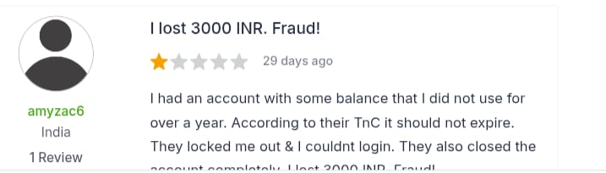
Fig 24.1 — Customer review describing an account lockout and loss of stored balance — illustrative of the broader trust risk this product's privacy and data-handling commitments must guard against.

25. Responsible AI & Privacy

25.1 Privacy Principles
- Body measurement and physical profile data is collected only with explicit, opt-in consent — never inferred or required to use the platform.
- Shoppers can view, edit, or delete their profile data at any time through account settings.
- Data retention windows are explicitly defined and enforced; inactive profiles are purged or anonymized on a defined schedule.
- Behavioral and transaction data used for modeling is handled under the same data protection standards as the rest of the platform's customer data — no separate, looser standard for AI features.

25.2 Fairness Commitments
- Risk scores and the Smart Shopper Score are periodically audited for disparate impact across body-type segments to ensure the system doesn't structurally disadvantage harder-to-fit shoppers.
- Explanations are reviewed for accuracy, not just plausibility — a stated reason must reflect an actual top contributing factor, not a generic plausible-sounding sentence.
- Alternative-product recommendations are monitored to ensure they don't systematically disadvantage smaller brands or newer SKUs (see Section 24).

25.3 Transparency Commitments
- Every shopper-facing prediction includes an explanation by design (Section 16) — explainability is treated as a requirement, not an enhancement.
- Shoppers are never penalized, blocked, or charged differently based on their risk profile — the system informs and suggests, but does not gate access or pricing.
- Internal model changes that materially affect prediction behavior are logged and reviewable (Section 15.3 model registry).

26. Roadmap (Phase 1–4)
Phase | Scope | Primary Objective
Phase 1 — Pilot | Single high-return category (e.g., denim/outerwear). Core engines only: User Profile, Product Intelligence, Return Risk Prediction, Return Reason AI, Return Prevention Mode. | Validate the core hypothesis (RRR) with a controlled A/B test before further investment.
Phase 2 — Category Expansion | Roll out validated core engines to additional apparel/footwear categories. Add Smart Size Recommendation and Alternative Product Recommender. | Prove the approach generalizes beyond the pilot category and scale the data asset.
Phase 3 — Advanced Personalization | Introduce Virtual Fit Simulator, One-Click Smart Checkout, Smart Shopper Score, and Future Return Prediction Timeline. | Deepen personalization and engagement once the core prediction layer is mature and trusted.
Phase 4 — Platform Maturity & Expansion | Daily Insights Automation at full scale; explore expansion beyond apparel/footwear (Section 28). | Operationalize the system as a standing platform capability and explore category expansion.

Sequencing Rationale
Advanced, data-hungry features (Virtual Fit Simulator, One-Click Checkout) are intentionally deferred to later phases — they depend on a mature, validated core risk model and a larger accumulated outcome dataset to perform reliably.

27. Business Model

27.1 Value Exchange
Stakeholder | What They Give | What They Get
Retailer / Platform | Access to transaction, return, catalog, and review data; infrastructure investment | Reduced return costs, preserved margin, merchandising insight, improved shopper trust
Shopper | Optional profile data (body measurements, preferences) | Personalized, explained guidance; fewer disappointing purchases; gamified recognition for good decisions
Brand / Supplier (indirect) | Product and sizing data via the retailer | Earlier, more specific signal on sizing inconsistencies than aggregate return-rate reporting alone

27.2 Monetization Pathways (for a Vendor Building This as a Product)
- Platform licensing — retailers license the engine as an integrated module within their existing e-commerce stack.
- Usage-based pricing — priced per prediction served or per order volume processed, aligning cost with the retailer's actual scale.
- Outcome-based / shared-savings pricing — a pricing tier tied to validated return-rate reduction, directly linking vendor revenue to the core KPI in Section 21.
- Tiered feature access — core risk prediction available at a base tier, with advanced personalization features (Phase 3 capabilities) available at a premium tier.

28. Future Expansion

28.1 Category Expansion
- Footwear — a natural near-term extension given similarly high fit-driven return rates.
- Home goods / furniture — “will this fit my space / match my expectations” is a structurally similar prediction problem.
- Electronics and appliances — expectation-mismatch risk (the dominant non-apparel return driver) could be addressed by the same Return Reason AI framework.

28.2 Capability Expansion
- Cross-platform body profile portability — letting a shopper's profile (with consent) inform predictions across multiple retailers, increasing cold-start accuracy.
- Supplier-facing sizing-correction recommendations — closing the loop by feeding aggregated risk-tag data back to brands to fix root-cause sizing inconsistency, not just predict around it.
- Conversational AI assistant layer — letting shoppers ask natural-language fit questions (“Will this run small if I usually wear a size 8?”) answered directly by the underlying engines.

28.3 Long-Term Vision Alignment
Each expansion path extends the same core thesis established in Section 6: a transparent, personalized, continuously learning trust layer placed at the moment of purchase decision — generalized beyond apparel into any category where “will I be satisfied with this” is uncertain before delivery.

29. Conclusion
The AI Return Reduction Engine reframes product returns as a predictable, preventable outcome rather than an unavoidable cost of online retail. By combining a user profile engine, a product intelligence engine, and an explainable risk-prediction model, the system intervenes at the one moment that matters most: before the purchase is confirmed.
Its long-term value lies less in any single prediction and more in the feedback loop it establishes — every purchase and every return makes the next prediction sharper. For e-commerce and fashion platforms carrying significant reverse-logistics cost, this kind of pre-purchase intelligence layer represents a direct path to lower returns, higher customer trust, and a more sustainable shopping experience.
The phased roadmap in Section 26 is deliberately conservative: validate the core hypothesis on a single category with a rigorous A/B test before scaling investment, ensuring the business case in Section 23 is built on real, measured outcomes rather than projected assumptions.

30. Appendix

30.1 Glossary
Term | Definition
Bracketing | The practice of ordering multiple sizes/variants of the same item with the intent to return the ones that don't fit.
Cold start | The condition of having insufficient historical data about a new user or new product to produce a high-confidence prediction.
Return Risk Score | A 0–100% probability estimate that a specific user will return a specific product.
Product Trust Score | A composite score reflecting a product's overall reliability based on reviews, return patterns, and listing quality.
Smart Shopper Score | A 0–100 gamified score reflecting a shopper's purchase accuracy and engagement with AI recommendations.
Self-Learning Loop | The automation that feeds every purchase/return outcome back into model retraining.
Explainable AI (XAI) | AI design practice ensuring predictions are accompanied by human-understandable reasons.

30.2 Reference Documents Index
- Section 12 — Detailed AI Engine specifications (engineering reference).
- Section 20 — PRD (requirements reference for engineering and QA).
- Section 21–23 — KPIs and A/B Testing Framework (analytics/data science reference).
- Section 25 — Responsible AI & Privacy (legal/compliance reference).

30.3 Visual Evidence Index
Nine real customer-review screenshots (Meesho, Myntra) are embedded directly in this document as evidence of the problem space. Their locations are listed below for quick reference:
- Fig 3.1–3.3 (Section 3.1) — Meesho reviews: late delivery, defective item with failed pickup, exchange-option failure.
- Fig 4.1–4.2 (Section 4.3) — Myntra reviews: product not matching listing, bulk order QC/fulfillment failure.
- Fig 5.1–5.2 (Section 5.2) — Myntra reviews: unstructured review sample illustrating the manual review-mining gap.
- Fig 9.1 (Section 9.1) — Myntra review: wrong product, refused exchange, no refund.
- Fig 24.1 (Section 24.1) — Account lockout/balance-loss review, supporting the data-sensitivity risk discussion.

